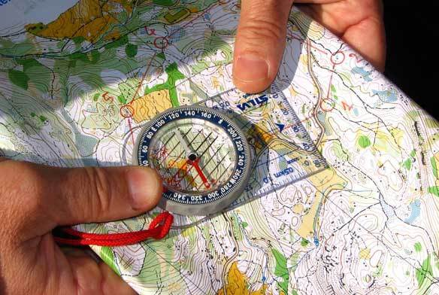
Activity: Orienteering Camporee
Location: Camp Brunswick (Eau Claire)
Dates: May 17-19, 2019
Departure: 5:30 p.m. Friday, CVBC
Est. Return: 12:00 p.m. Sunday, CVBC
COST: $22.00 ($12/four meals; $10 camporee fee)
Emergency contact:
Steve Seiberling's cell phone: 715-456-3749

Details: The BSA Council Camporee this spring features the Orienteering Merit Badge. It will be held at the Council's newest camp, Camp Brunswick, just southwest of Eau Claire (less than a half hour drive from CVBC). Scouts should be able to complete many of the requirements for the Orienteering Merit Badge at this event. Please bring a quality compass if you have one! Retain the above information and return the form below with any money by 7:00 p.m. Monday, May 13, 2019. Patrols will be buying food that night.

- - - - - - - - - - - - - - - - - (cut here; return bottom portion) - - - - - - - - - - - - - - - - - - - - - -

Orienteering Camporee at Camp Brunswick
Dates: May 17-19, 2019
Fees: $______ (account) + $_______ (cash) + $______ (check) = $22.00
(make checks payable to "Troop72.com")

In consideration of the benefits to be derived, and in view of the fact that the Boy Scouts of America is an educational institution, membership in which is voluntary, and having full confidence that every precaution will be taken to ensure the safety and well-being of my Scout son/ward, namely:

First_________________________________________ MI____________ Last_________________________________________
on the activity above, I agree to his participation and waive all claims against the leaders of this trip, officers, agents and representatives of the Boy Scouts of America, and the sponsoring organization, Chippewa Valley Bible Church. In the event of an emergency, the troop leader of the activity named above has my permission to obtain medical treatment for this Scout at the nearest hospital or doctor, at my expense, if our own doctor is not readily available, and as restricted on the medical form on file with the Troop.
[ ] Yes, I will attend this activity with my son(s)
[ ] Yes, I can drive the troop trailer to/from the campsite

Signature of parent or guardian:____________________________________________ Date:_____________________

EMERGENCY INFORMATION ON FILE?
[ ] Yes, I have an updated medical form on file with the troop.
[ ] No, I still have to fill out that medical form and get it to the troop.
[ ] The following is new information since the medical form was filed:

Questions? Call Tom Arneberg (715-726-1728), or see the www.troop72.com web page.

