
Activity: “DuraBiT”: 72-mile Durand Bike Trip
Location: Lake Hallie -> Durand and back
Dates: Sat-Sun, July 20-21, 2019
Meet at: 8:00 a.m. Sat, Hardee's (B53/Eddy Ln.)
Est. return: 3-5 p.m. (?) Sun, Hardee's (B53/Eddy Ln.)
Cost: $12 (3 meals @ $3.00 + $3 for pool)

Emergency contact: Tom Arneberg's cell: 715-338-1407
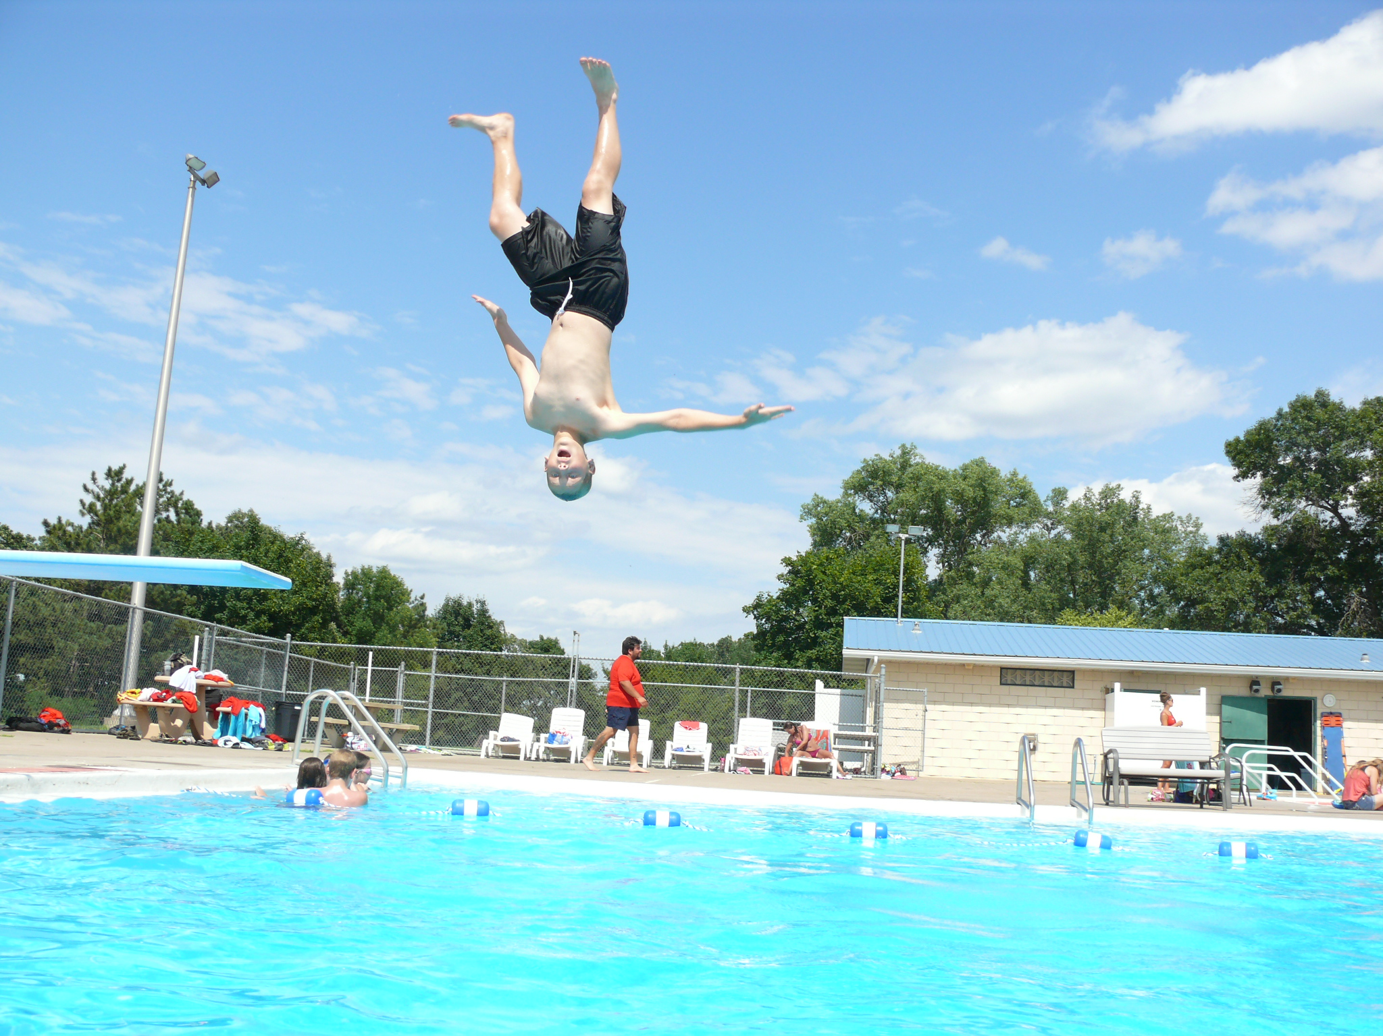
Details: We are heading back to Durand on our annual bike trip! We'll haul camping/cooking gear from Hardee's to Durand in the troop trailer, so the burden will be light. We'll be bicycling entirely on paved bike trails, on the Chippewa River Trail, through Eau Claire, and on to Durand. The trail is paved and flat, but it is about 36 miles each day, so boys should bring a bike in good working order, and should try to do a little conditioning before the trip. Also, helmets are mandatory (along with Troop72 red “action” shirts). (We may be offering a 50-mile option on Saturday for those who want to ride a little further, by taking a side trip to Downsville; that would fulfill one of the requirements for the Cycling Merit Badge.) You can eat breakfast at home, or at Hardee's if you arrive before 8:00. (If you've never gone 36 miles in a day, don't worry; it's easier than you think...we've had plenty of 11-year-olds able to make it, and even a couple 9-year-olds.) Good news – because we’re not doing it in August this year, the POOL WILL BE OPEN! We'll be stopping at Dairy Queen near Carson Park on the ride home, and possibly at the DQ in Durand on Saturday, too, so bring money if you want extra treats. Bring a lunch from home to eat halfway on Saturday.

Retain the above information and return the form below with any money by 8:00 a.m. Saturday, July 21, 2019.

- - - - - - - - - - - - - - - - - - (cut here; return bottom portion) - - - - - - - - - - - - - - - - - - - - - -
“DuraBiT”: 72-mile Durand Bike Trip (Lake Hallie -> Durand and back)
Dates: Sat-Sun, July 20-21, 2019
Fees: $______ from boy's account + $______ enclosed check* = $12.00
(*make your check payable to “Troop 72”)
In consideration of the benefits to be derived, and in view of the fact that the Boy Scouts of America is an educational institution, membership in which is voluntary, and having full confidence that every precaution will be taken to ensure the safety and well-being of my Scout son/ward, namely:

First_________________________________________ MI____________ Last_________________________________________
on the activity above, I agree to his participation and waive all claims against the leaders of this trip, officers, agents and representatives of the Boy Scouts of America, and the sponsoring organization, Chippewa Valley Bible Church. In the event of an emergency, the troop leader of the activity named above has my permission to obtain medical treatment for this Scout at the nearest hospital or doctor, at my expense, if our own doctor is not readily available, and as restricted on the Emergency Data Sheet on file with the Troop.
[ ] Yes, I will attend this activity with my son(s)
[ ] Yes, I can drive the troop trailer to/from the campsite

Signature of parent or guardian:_______________________________________ Date:_____________________

EMERGENCY INFORMATION ON FILE?
[ ] Yes, I have an updated medical form on file with the troop.
[ ] No, I still have to fill out that medical form and get it to the troop.
[ ] The following is new information since the medical form was filed:

Questions? Call Tom Arneberg (715-726-1728), or see the www.troop72.com web page.

