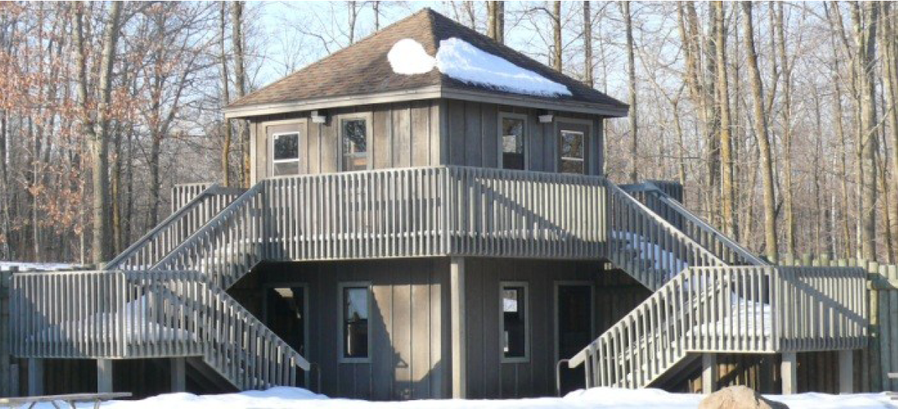
Activity: Fort Rice Campout
Location: LE Phillips Scout Reserv.
Dates: Nov. 10-12, 2023
Departure: 5:30 p.m. Friday, CVBC
Est. Return: 11:30 a.m. Sunday, CVBC
COST: $40 ($20/4 meals; $20/cabin)
Emergency contact: Camp office, 715-234-1147
or Steve Seiberling's cell phone: 715-456-3749

Details: It's that time of year again when we give up the tents and enter CABIN CAMPING! And not just any cabin, but the biggest one out there – the famed FORT RICE, complete with its 20 bunks upstairs and four different towers each with their own bunks. (And beds on the main floor for the dads.) Our older Scouts have traditionally set up a compass course for the younger Scouts to navigate as part of their 2nd Class Hiking and/or 1st Class Navigation requirements.

With the weekend nestled between fall and winter sports, and a week before gun hunting season, this is always our troop's biggest campout of the year. We have had as many as 47 people at this one before, with room to spare.

Retain the above information and return the form below with any money by 7pm on Monday, Nov. 6, 2023. We will be buying food that night. Unlike most trips, where each patrol cooks its own meals, we will coordinate our efforts to produce a big preThanksgiving feast for Saturday supper, complete with the legendary Trashcan Turkey, mashed potatoes and gravy, stuffing, corn, and probably pumpkin pie. (This would be a GREAT trip to bring friends to! Plenty of room, awesome food, and great Scouting adventures await!)

- - - - - - - - - - - - - - - - - (cut here; return bottom portion) - - - - - - - - - - - - - - - - - - - - - -

Fort Rice at L.E. Phillips Scout Reservation
Dates: Nov. 10-12, 2023
Fees: $_____ from Scout's account + $_____ cash + $_____ enclosed check = $40
(make checks payable to "Troop72.com")

In consideration of the benefits to be derived, and in view of the fact that the Boy Scouts of America is an educational institution, membership in which is voluntary, and having full confidence that every precaution will be taken to ensure the safety and well-being of my Scout son/ward, namely:

First_________________________________________ MI____________ Last_________________________________________
on the activity above, I agree to his participation and waive all claims against the leaders of this trip, officers, agents and representatives of the Boy Scouts of America, and the sponsoring organization, Chippewa Valley Bible Church. In the event of an emergency, the troop leader of the activity named above has my permission to obtain medical treatment for this Scout at the nearest hospital or doctor, at my expense, if our own doctor is not readily available, and as restricted on the medical form on file with the Troop.
[ ] Yes, I will attend this activity with my son(s)
[ ] Yes, I can drive the troop trailer to/from the campsite

Signature of parent or guardian:____________________________________________ Date:_____________________

Parent/Guardian contact phone number:_______________________________________

EMERGENCY INFORMATION ON FILE?
[ ] Yes, I have an updated medical form on file with the troop (less than a year old).
[ ] No, I still have to fill out that medical form and get it to the troop.
[ ] The following is new information since the medical form was filed:

