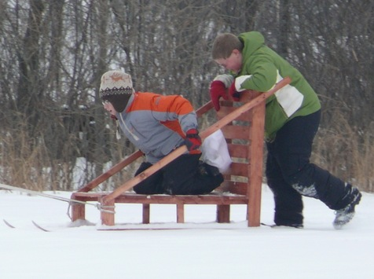
Activity: Klondike Derby!
Location: LE Phillips Scout Reserv.
Dates: Jan. 10-12, 2025
Departure: 5:30 p.m. Friday, CVBC
Est. Return: 11:30 am Sunday, CVBC
COST: $30 ($12/3 meals; $15/fee, $3 cabin)
Emergency contact: Camp office, 715-234-1147
or Steve Seiberling's cell phone: 715-456-3749

Details: The Klondike Derby is one of the most exciting campouts of the year! For those who haven't been to one, a klondike derby is an event where each patrol pushes around a big home-made sled. (We'll need to either find some old sleds or build new ones, or pull a regular sled with a rope.) The sled contains things like a first aid kit, matches, blankets, knives, and pots. There are string-burning contests, sled races, tight-rope gold-scooping, the Ravine of Death, ax skill tests, and boiling water – all outdoors, just like the real Alaskan Klondike! There are also races and other competitions to test your agility. (See our "Troop72.com" web page for links to more information.)

It will be held at Camp Phillips, about an hour's drive up Highway 53. We will have one of the cabins in the winter camp area, hopefully the Baden-Powell Lodge again with gas heat and a kitchen area and this year, even indoor bathrooms and showers and a FIREPLACE. Scouts are welcome to try sleeping outside, too!

Retain the above information and return the form below with any money by 7pm on Monday, Jan. 6, 2025

- - - - - - - - - - - - - - - - - (cut here; return bottom portion) - - - - - - - - - - - - - - - - - - - - - -

Klondike Derby at L.E. Phillips Scout Reservation
Dates: Jan. 10-12, 2025
Fees: $_____ from Scout's account + $_____ cash + $_____ enclosed check = $30
(make checks payable to "Troop72.com")

In consideration of the benefits to be derived, and in view of the fact that the Boy Scouts of America is an educational institution, membership in which is voluntary, and having full confidence that every precaution will be taken to ensure the safety and well-being of my Scout son/ward, namely:

First_________________________________________ MI____________ Last_________________________________________
on the activity above, I agree to his participation and waive all claims against the leaders of this trip, officers, agents and representatives of the Boy Scouts of America, and the sponsoring organization, Chippewa Valley Bible Church. In the event of an emergency, the troop leader of the activity named above has my permission to obtain medical treatment for this Scout at the nearest hospital or doctor, at my expense, if our own doctor is not readily available, and as restricted on the medical form on file with the Troop.
[ ] Yes, I will attend this activity with my son(s)
[ ] Yes, I can drive the troop trailer to/from the campsite

Signature of parent or guardian:____________________________________________ Date:_____________________

Parent/Guardian contact phone number:_______________________________________

EMERGENCY INFORMATION ON FILE?
[ ] Yes, I have an updated medical form on file with the troop (less than a year old).
[ ] No, I still have to fill out that medical form and get it to the troop.
[ ] The following is new information since the medical form was filed:

