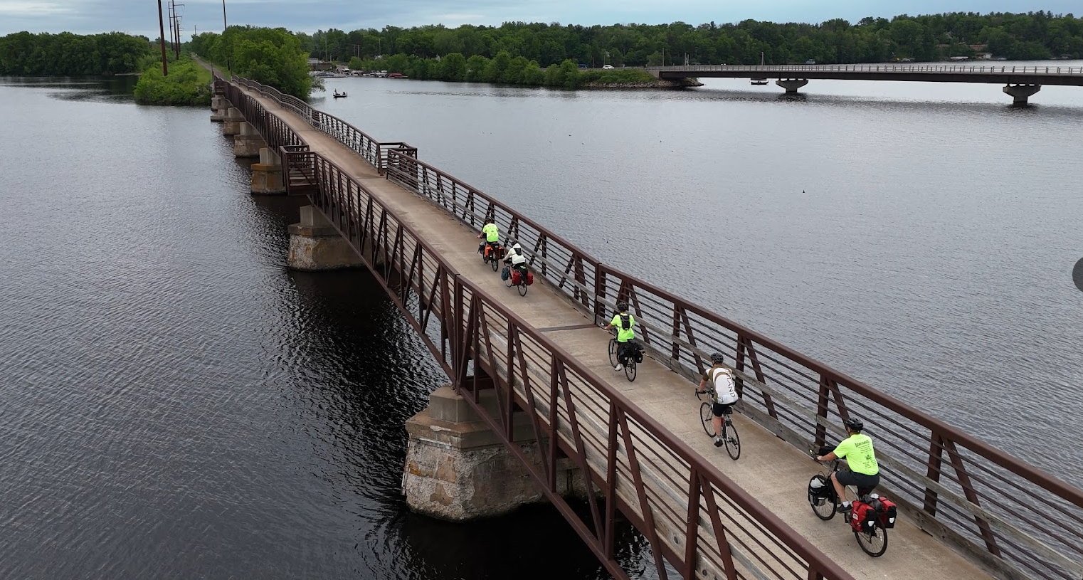
Activity: COBIRD (Cornell Bike Ride)
Location: Brunet Island State Park
Dates: Sept. 27-28, 2025
Departure: 10:00, CVBC
Est. Return: 1:30 p.m.? Sunday, CVBC
COST: $6.00 ($6 for four meals)
Emergency contact: Tom Arneberg's cell phone: 715-338-1407

Details: We're taking advantage of the magnificent fall weather, and heading north on one last bike trip for 2025! It's about 25 miles from CVBC to Brunet Island State Park, all on paved off-road bike trails (the Old Abe Trail). We will buy groceries in Cornell for supper Saturday and breakfast Sunday, but bring extra food and/or money if you want to buy anything for lunch either day, or ice cream in Cornell. Retain the above information and return the form below with any money by 10:00 a.m. Saturday, Sept. 27, 2025.

- - - - - - - - - - - - - - - - - (cut here; return bottom portion) - - - - - - - - - - - - - - - - - - - - - -

COBIRD (Cornell Bike Ride)
Dates: Sept. 27-28, 2025
Fees: $______ (account) + $_______ (cash) + $______ (check) = $6.00
(make checks payable to "Troop72.com")

In consideration of the benefits to be derived, and in view of the fact that the Boy Scouts of America is an educational institution, membership in which is voluntary, and having full confidence that every precaution will be taken to ensure the safety and well-being of my Scout son/ward, namely:

First_________________________________________ MI____________ Last_________________________________________
on the activity above, I agree to his participation and waive all claims against the leaders of this trip, officers, agents and representatives of the Boy Scouts of America, and the sponsoring organization, Chippewa Valley Bible Church. In the event of an emergency, the troop leader of the activity named above has my permission to obtain medical treatment for this Scout at the nearest hospital or doctor, at my expense, if our own doctor is not readily available, and as restricted on the medical form on file with the Troop.
[ ] Yes, I will attend this activity with my son(s)
[ ] Yes, I can drive the troop trailer to/from the campsite

Signature of parent or guardian:____________________________________________ Date:_____________________

EMERGENCY INFORMATION ON FILE?
[ ] Yes, I have an updated medical form on file with the troop.
[ ] No, I still have to fill out that medical form and get it to the troop.
[ ] The following is new information since the medical form was filed:

Questions? Call Tom Arneberg (715-339-1407), or see the www.troop72.com web page.

