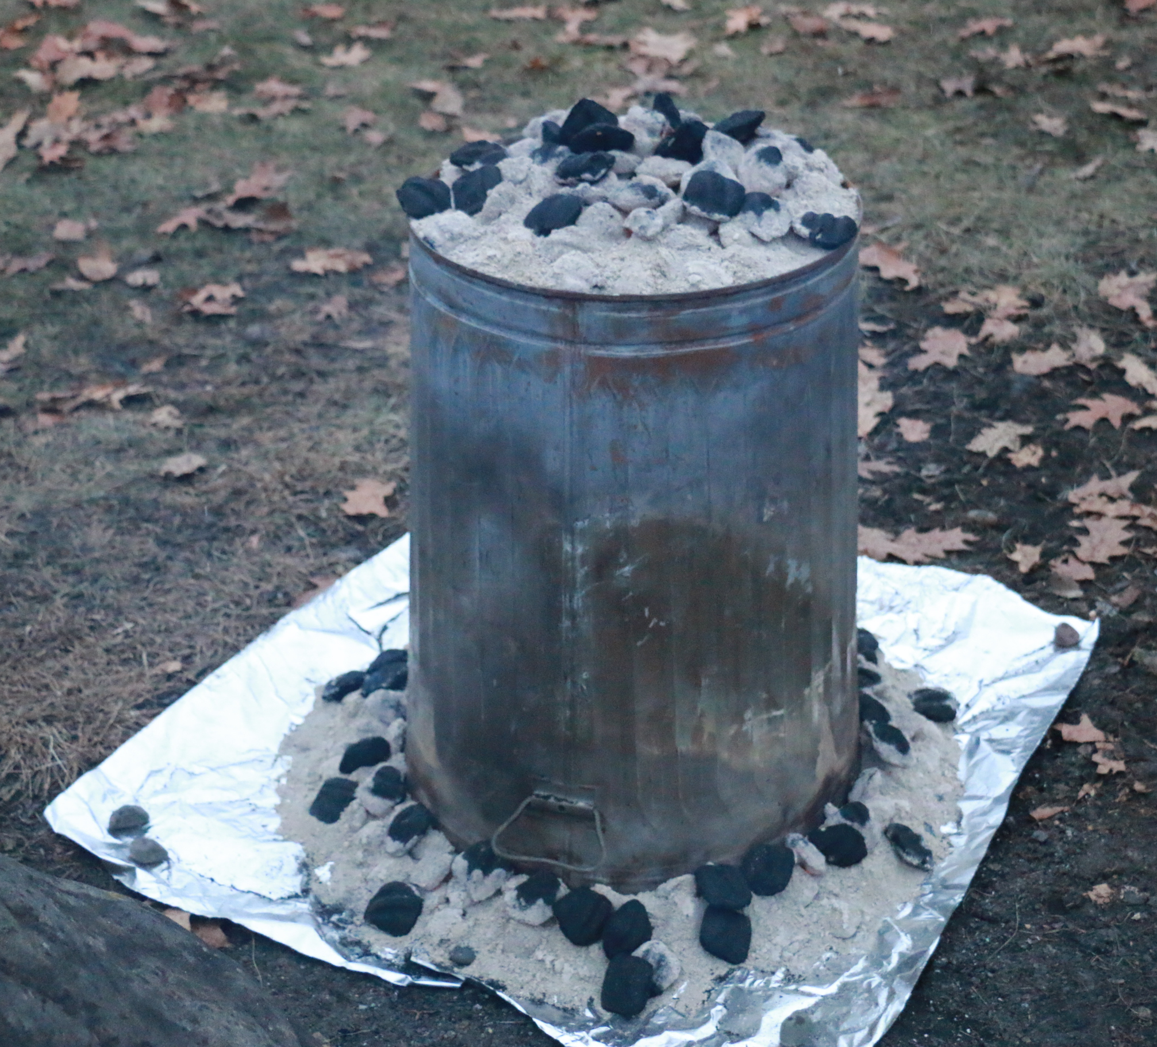
Activity: “FORT POWELL” CAMPOUT
Location: L.E. Phillips
Dates: Fri-Sun, Nov. 7-9, 2025
Meet at: 5:30 p.m. Fri, CVBC
Est. Return: 11:30 a.m. Sun, CVBC
Cost: $30 (4 meals; $10 cabin)
Emergency contact: Gary Gilles: 715-577-8321

Details: It's that time of year again when we give up the tents and hit the cabins! We're headed once again to the amazing L.E. Phillips Scout Reservation property (just west of Haugen, about 55 miles north of Chippewa Falls). We are not large enough to get the coveted Fort Rice compound reserved, but we do get another great cabin, the Baden-Powell Lodge. This is the second best cabin at Phiillips – shower, two bathrooms, and even a real fireplace! Specific activities are to be determined by our PLC, but traditionally have included a long hike and a compass course. Many other opportunities for requirements will abound!

Retain the above information and return the form below with any money by 7:00 p.m. Monday, Nov. 3, 2025. We will be buying food that night. Unlike most trips, where each patrol cooks its own meals, we will coordinate our efforts to produce a big pre-Thanksgiving feast for Saturday supper, complete with the famous Trashcan Turkey, mashed potatoes and gravy, stuffing, corn, and probably pumpkin pie. (This would be a GREAT trip to bring friends to! Plenty of room, awesome food, and great Scouting adventures await!)

- - - - - - - - - - - - - - - - - - (cut here; return bottom portion) - - - - - - - - - - - - - - - - - - - - - -
Activity: November Cabin Campout
Dates: Fri-Sun, Nov. 7-9, 2025
Fees: $______ from boy's account + $______ enclosed check* = $25.00
(*make your check payable to “Troop 72”)
In consideration of the benefits to be derived, and in view of the fact that the Boy Scouts of America is an educational institution, membership in which is voluntary, and having full confidence that every precaution will be taken to ensure the safety and well-being of my Scout son/ward, namely:

First_________________________________________ MI____________ Last_________________________________________
on the activity above, I agree to his participation and waive all claims against the leaders of this trip, officers, agents and representatives of the Boy Scouts of America, and the sponsoring organization, Chippewa Valley Bible Church. In the event of an emergency, the troop leader of the activity named above has my permission to obtain medical treatment for this Scout at the nearest hospital or doctor, at my expense, if our own doctor is not readily available, and as restricted on the medical form on file with the Troop.
[ ] Yes, I will attend this activity with my son(s)
[ ] Yes, I can drive the troop trailer to/from the campsite

Signature of parent or guardian:____________________________________________ Date:_____________________

EMERGENCY INFORMATION ON FILE?
[ ] Yes, I have an updated medical form on file with the troop.
[ ] No, I still have to fill out that medical form and get it to the troop.
[ ] The following is new information since the medical form was filed:
Questions? Email Tom Arneberg (Tom@Arneberg.com), or see the www.troop72.com web page.

